AIM: To implement the K-Nearest Neighbors (KNN) classification algorithm in Python to classify student results based on hours studied, attendance, and assignments, and evaluate the model using accuracy, confusion matrix, and classification report.
ALGORITHM:
- Start the program.
- Import the required libraries: Pandas and Scikit-learn.
- Load the student dataset from the data.csv file.
- Remove extra spaces from the column names.
- Select Hours studied, Attendance, and Assignment as input features.
- Select Result as the target variable.
- Split the dataset into training and testing sets in an 80:20 ratio.
- Create a KNN classifier with n_neighbors=3.
- Train the model using the training data.
- Predict the results for the testing data.
- Calculate and display the model's accuracy.
- Display the confusion matrix using the pass and fail labels.
- Display the classification report, including precision, recall, and F1-score.
- Stop the program.

OUTPUT:
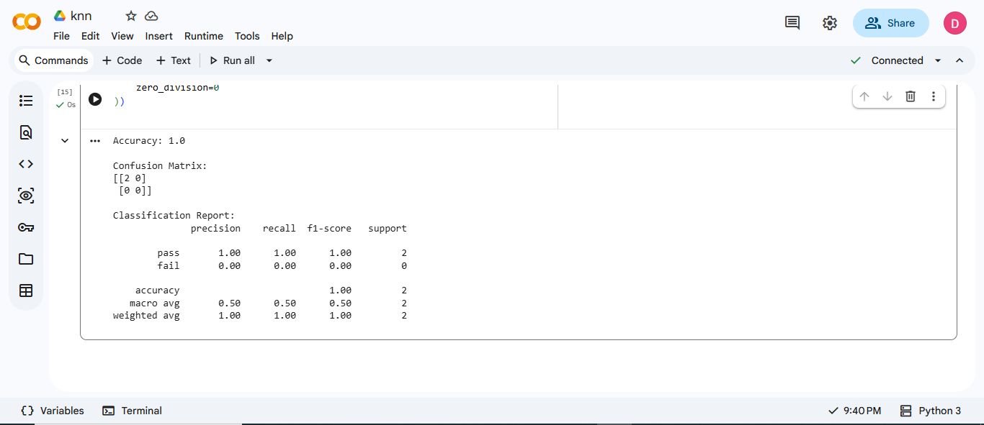

RESULT: Thus, the K-Nearest Neighbors (KNN) classification algorithm was successfully implemented in Python to classify student results based on hours studied, attendance, and assignments. The model was evaluated using accuracy, confusion matrix, and classification report. The model achieved 100% accuracy on the two test samples.

